GrapeVine  “Offering Unique Ministries Rooted in God’s Love”  Trinity Federated Church  Naples, New York  Trinity Federated Church of Naples (Facebook) tfc14512@gmail.com https://trinityfederatedchurch.org (website) (585) 374-5017  March 2026 Issue 0326      Stu’s News  Good afternoon,  We are only a few days away from the beginning of Lent and the sun is shining gloriously. While it may be difficult in the southern hemisphere to have Christmas in the summertime, I’ve never heard anyone complain about Lent getting brighter, longer days and warmer.  So what will you do this year for Lent? Some people think that the reason churches are shrinking is that they are not challenging at all.  If that’s true, what could each of us do, this Lent, that would be challenging? Fasting can take many shapes and sizes. For example, you could wait until after 11 to have your first hot drink or any kind of food and that could be a fast. You could also abstain from any number of different foods, activities or experiences and also consider that a fast. If however, you have no reason for doing these things, there’s no point in doing them.  It might be an interesting question to explore what you think God would like you to do this Lent. It would be interesting to know how you came to that answer and how you respond to that challenge over the course of the next few weeks.  I continue to realize how little I read scripture but then I also recognize that I might read several chapters and have no memory of it when I’m done.  So my question to you and to myself is, will this Lent be meaningful?  Stu |   9:30 am & 11 am Sunday Worship in the sanctuary & via Facebook Live _____________________________  Articles In the Grapevine  Stu’s News Pg. 1 Lent  TFC News Pg. 2  - Services  - Senior Luncheons of Naples, NY  - Come Pre-Prayered  - Church Calendar  - Our Prayer List  - Current Missions  Naples News Pg. 3  - Women’s Weekend  Naples News Pg. 4  - It Takes a Village  - Women- Paige Howard  - Next Topic: Spring
TFC NEWS Second Sunday and Saturday Services! On March 8, we will have a 9:30 AM service but won’t have our 11 AM service. There will be a 4 PM service in person Saturday, March 7! DON’T FORGET TO SET YOUR CLOCKS BACK SUNDAY!  Come Pre”prayer”ed Sermons New Time! 5 PM Chats 3.1.26- “I’ll Come With You” 3.1.26-No Chat! Matthew 8:5-13  3.7&8.26 “Better Than Aspirin" 3.8.26-Prayer-singing Matthew 8: 14-17 (BYO Snacks, Drinks and Tableware) SATURDAY SERVICE AT 3 PM!! 3.15.26- “Lord, Rescue Us” 3.15.26-Prayer-singing Matthew 8: 23-27 (BYO Snacks, Drinks and Tableware)  3.22.26- “What Are You Going to Do With Us?” 3.22.26-Prayer-singing Matthew 8: 28-34 (BYO Snacks, Drinks and Tableware)  3.29.26- “What Do You Shout/Hear?” 3.29.26-Prayer-singing Matthew 21:1-11 (BYO Snacks, Drinks and Tableware) (Palm Sunday)  February Missions at TFC: Collecting Food for Naples Open Cupboard and Can Drive for Courtney  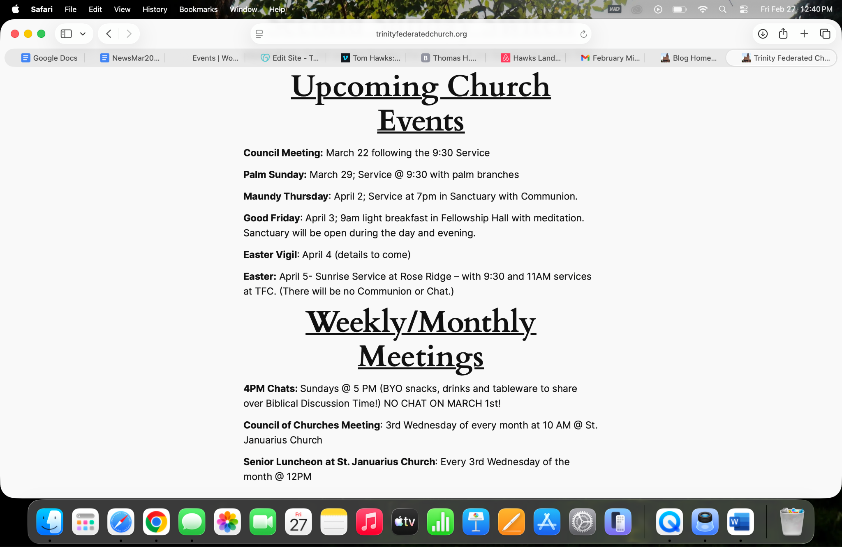 |   Taylor Cochrane 55 East Avenue Naples, NY 14512  Sharon Fox 14 West Ave. Naples, NY 14512  Ruth Rohlin 1177 E Henrietta Rd. Rochester, NY 14623  Senior Luncheons Of Naples, NY  Senior Luncheons are coming to you right here in Naples! Every 3rd Wednesday of the month at 12pm the Senior Luncheons are hosted by the Council of Churches at St. Januarius Church! This month’s Luncheon is on March 18 and will be serving macaroni and cheese, salad, and a chocolate chip cookie! All luncheons are free, but if you have a wish to donate, you can donate at the St. Januarius luncheon where all proceeds will go to the Naples Open Cupboard! See you there!
Naples News: Women’s Weekend
As you know, Women’s Weekend is back for its third year in a row, coming your way March 6-8 and with it so close, we can now give you the more detailed concept of the goings on!
Below are the list of events happening right here at Trinity Federated Church plus don’t forget to stop at the former little bunch building to see the Artful Boutique which has tons of pop up shops, services and info at the central hub for women’s weekend! There are so many events happening all over Naples this weekend for you to check out but definitely stop by TFC for all the amazing events happening next weekend!
FRIDAY-
9:30am-2:30pm: In front of Trinity Church
Mobile Mammography Van
Sign up for an appointment by calling 1-844-870-0002 or emailing mammovan@urmc.rochester.edu

4:00pm-5:00pm: Trinity Church - Upper Room, 119 N. Main St.
Yoga + Journaling With Pauline Johnson of MushYoga
A gentle, grounding yoga practice followed by guided journaling to help you reflect and reset. Please bring your own journal and pen. Suggested Donation $10-$20 Let me know you’ll be there: https://linktr.ee/MushYoga

SATURDAY-
8:00am-9:00am: Trinity Church - Upper Room, 119 N. Main St.
Vinyasa Yoga with Pauline Johnson of MushYoga
A faster-paced, energizing flow linking breath and movement to build strength and mobility.
Suggested Donation $10-$20 Let me know you’ll be there: https://linktr.ee/MushYoga

9:00am-10:00am: Trinity Church - Upper Room, 119 N. Main St.
Kundalini Yoga for Self-trust & Intuition led by Shanna
*Suggested Donation $15

10:00am-11:00am: Trinity Church - Upper Room, 119 N. Main St.
Soul Light Sound Therapy with Jennifer Cervantes. All welcome! Suggested Donation $0-$10 Registration preferred but not required at: soullightsoundtherapy@gmail.com

11:00am-12:00pm: Trinity Church - Lower Room, 119 N. Main St.
The Love of Water
Are you curious what wisdom water may hold? Learn what indigenous cultures have never forgotten; water is not a resource, it is a source of unique intelligence, and a connection.
Suggested Donation $30 Limited to 12 Participants
Please pre-register at: FLForestTherapy@gmail.com

1:00pm-2:00pm: Trinity Church - Lower Room, 119 N. Main St.
SPRING SUCCULENT PLANTERS Make and Take Workshop
Join me in creating a beautiful Spring Succulent Planter! All supplies and succulents provided! Suggested Donation is $30 TO REGISTER PLEASE TEXT KATE by 3/1 at: 585-245-2115

2:00pm-3:00pm: Trinity Church - Upper Room, 119 N. Main St.
Gentle Yoga & Sound Bath with Jodi Simons Caruso & Suzanne Frazer. Together Jodi and Suzanne bring over 25 years of teaching experience in yoga, meditation, sound bathing, and group healing.
Suggested Donation: $0-$20. All welcome!

SUNDAY-
12:00pm-1:00pm: Trinity Church - Upper Room, 119 N. Main St.
Move, Breathe, Meditate with Pauline Johnson of MushYoga
An intentional blend of yoga movement, breathwork, and meditation.
Suggested Donation $10-$20
Let me know you’ll be there: https://linktr.ee/MushYoga

1:00pm: Trinity Church
Women Speak
Woman Speak is a community-centered open mic and women’s circle created to offer a safe, welcoming space for women to share their voices, stories, creativity, and lived experiences.
**FREE Experience**

3:30pm-4:00pm: Trinity Church - Upper Room, 119 N. Main St. Restorative Meditation with Pauline Johnson of MushYoga
A deeply restful mini Yoga Nidra experience to help you fully relax and recharge. Perfect for closing the weekend with ease & presence. Suggested Donation $5.00-$10 Let me know you’ll be there: https://linktr.ee/MushYoga

4:00pm: Trinity Church - Upper Room, 119 N. Main St.
CLOSING CIRCLE
Let's celebrate the unforgettable weekend we've shared, paying tribute to the trailblazing women who paved the way and let us continue to blaze that path for the generations of women to come. Let’s be joyous in song & dance, embracing the uniqueness of all of us! Keep blazing that trail!

It Takes a Village!
Welcome back to it takes a village!
Here’s how it works:
- Each newsletter, I choose a topic for the next month’s newsletter. APRIL TOPIC: SPRING
- You send me a positive piece that is written, photographed, painted, etc that represents the topic chosen! All submissions must be sent to tfc14512@gmail.com by the 21st of each month (be aware that all printed copies are in b&w but the online version is in color)
- I will review the pieces and will select 1-3 items to be included in the newsletter. (If nothing is sent to me for any given month, I will create something for that specific topic)
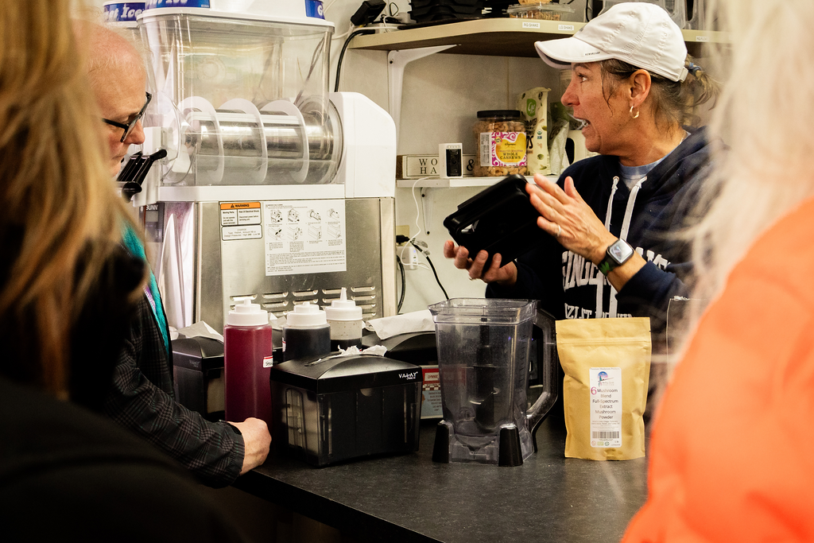
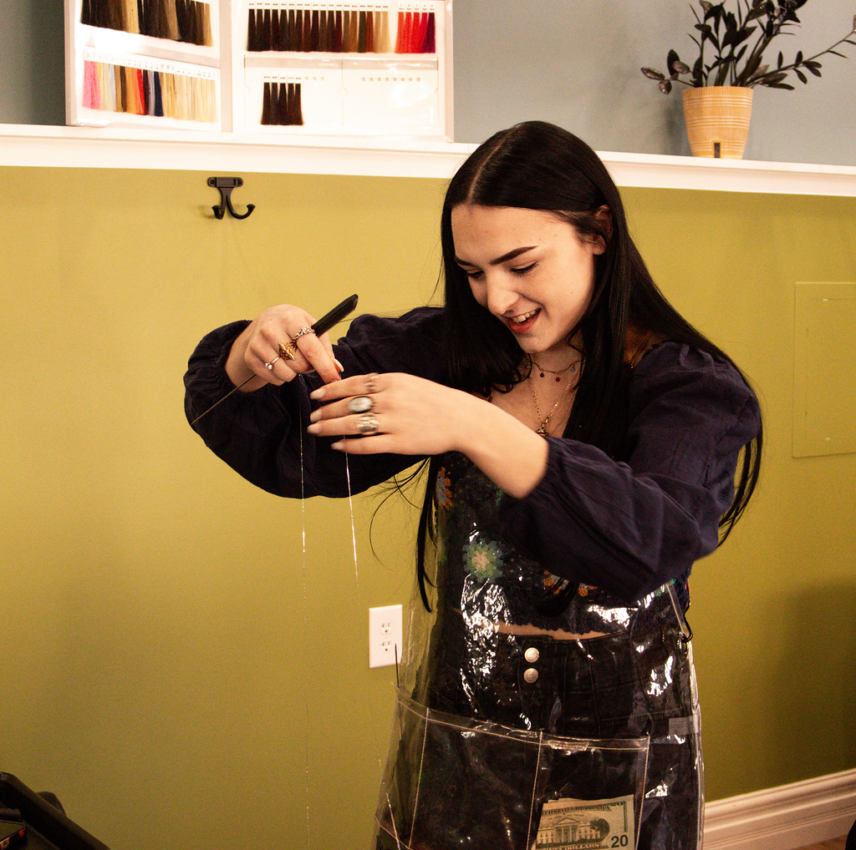
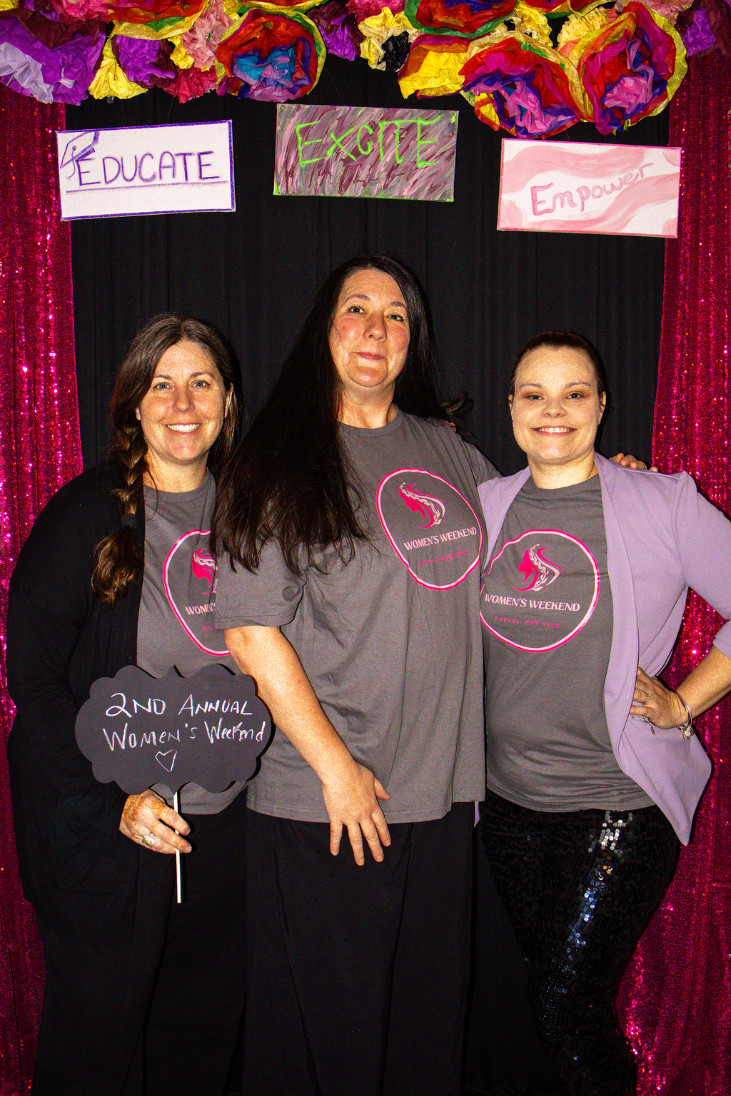
With no submissions from the community for the month of March’s topic, Women, I will showcase some photographs that I took of our community at last year’s Women’s Weekend event!
