TRINITY FEDERATED CHURCH
Email: tfc14512@gmail.com 123 N Main St, Naples, NY 14512
Website: https://trinityfederatedchurch.org Church Phone: 374-5017
FB: @TrinityFederatedChurchofNaples Pastor’s Phone: 716-713-6488
Contemporary Service: 9:30 am Traditional Service: 11 am
------------------------------------------------------------------------------------------------------------------------------------------------------------------------------
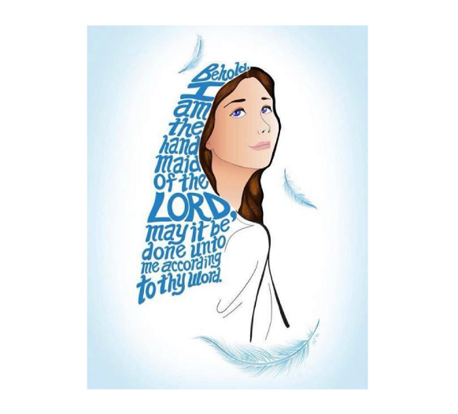
December 21, 9:30am Worship

Silent Prayer of Preparation: There were some women watching.

Gathering Songs:
“Imagine”
“God help us to treasure”
“Angels we have, Infant Holy” (first verse)

Bells “He is Born”; “Hark the Herald Angels Sing”
Tolling of the Bell/Welcome
Prayer for Peace: “Where Shepherd” vs3

Lighting the Advent wreath: Sherie and Mike Heins, Tad and Angie Barton
Mary is found to be with child, Emmanuel, God is with us, we are not alone, nor afraid.
The birth of a child, the beginning of a new life has much to celebrate and rejoice in.
We light the fourth Advent candle of joy, springing up within us!

Candle song: “Hope is a candle” v4 joy

Celebrations (money is not required, any money received goes to meet needs through Naples Angels.)

Prayers of the People/ Lord’s Prayer

Young People’s time: “Decorating for Christmas” members of the congregation.

Hymn: “It’s rounded” ch 292 (Please stand if you are able)
Prayer of Confession: (Unison) When something happens, Lord, we do not always attribute it to you, forgive us. Forgive us for what we take for granted. (please pray silently). Create in me a new life oh Lord, help me be like you in all I do, in Christ we pray. Amen.
Assurance of Pardon
When we tell our sins to God, God forgives us and cleanses our soul.
The Good news is that in Christ we are forgiven, alleluia!

Response: “Creator of the stars” P4 vs 4

Passing of the peace

Prayer for Illumination: “Where shepherds” vs4

Psalm 24 Response: Sing, believers. Give thanks for those whose joy is in the Lord.
New Testament Lesson: Matthew 1: 18, 23; Luke 1:26-38
These are the Words of the Lord: Thanks be to God
Sermon: “Women – No wind at the window” Rev. Stuart C. Buisch

Creed: (Unison) (Please stand if you are able)
What is your only comfort in life and in death?
That I am not my own, but belong- body and soul, in life and in death-to my faithful savior, Jesus Christ. Because I belong to him, Christ by his Holy Spirit, assures me of eternal life and makes me wholeheartedly willing and ready from now on to live for him. Heidelberg Catechism

Hymn: “Who would think” CH 295 (Please stand if you are able)

Charge (Unison) Live at peace with each other. Comfort the discouraged. Help the weak. Be patient with everyone. Make sure no one repays a wrong with a wrong, but always pursue the good for each other and everyone else. Rejoice always. Pray continually. Give thanks in every situation because this is God’s will for you in Christ Jesus. I Thess

Benediction

Song: “The Angel Gabriel” P16 v 4

Question: When did you last experience joy?

Announcements
4 PM Chat: Topic- More Women
Missions- Courtney’s Can Crusade
Collecting food & winter gear for Naples Open Cupboard & winter gear for NCS

Upcoming Events
Christmas Eve- 3PM (short); 6PM (candlelight)

