TRINITY FEDERATED CHURCH
Email: tfc14512@gmail.com 123 N Main St, Naples, NY 14512
Website: https://trinityfederatedchurch.org Church Phone: 374-5017
FB: @TrinityFederatedChurchofNaples Pastor’s Phone: 716-713-6488
Contemporary Service: 9:30 am Traditional Service: 11 am
------------------------------------------------------------------------------------------------------------------------------------------------------------------------------
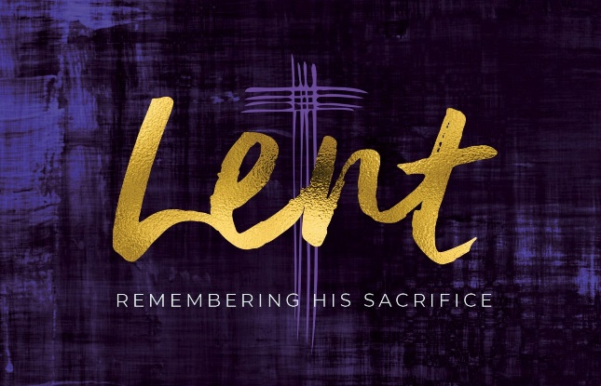
March 22, 9:30am Worship

Silent Prayer of Preparation: Sometimes asking gives you what you don’t want.

Gathering Songs:
Awesome God 2040
Step by step
You are my all in all 3040

Tolling of the Bell/Welcome

Prayer for Peace: “My Song is Love” P76 V5

Call to Worship:
In our day to day we meet obstacles and road blocks and we lose our way and light.
Demoniacs lose their independence and their way until Christ sets them free.
Getting rid of a few demons can eat up a lot of extra things that we don’t expect.
We gather together to be with you God, to grow in our trust and to praise You.

Celebrations (money is not required, any money received goes to meet needs through Naples Angels.)

Prayers of the People/ Lord’s Prayer

Young People’s time

Hymn: “What wondrous Love” (Please stand if you are able) P85
Prayer of Confession: (Unison) Sometimes Lord, we miss the point. We encounter situations that we think we can handle which are way over our heads and souls. Forgive us and help us to be aware when we should turn to you for help. (please pray silently). Create in us new life oh Lord, help us shine you in all we do, in Christ we pray. Amen.
Assurance of Pardon
When we tell our sins to God, God forgives us and cleanses our soul.
The Good news is that in Christ we are forgiven, alleluia!

Response: “Water, River, Spirit, Grace” 2253

Passing of the peace

Prayer for Illumination: “Open our eyes” MP545

Psalm 16 Response: Protect me O God, Lord, I take refuge in you.
New Testament Lesson: Matthew 8: 28-34
These are the Words of the Lord: Thanks be to God
Sermon: “Season of Lent: What are you going to do with Us?” Rev. Stuart C. Buisch

Creed: (Unison) (Please stand if you are able) In a broken and fearful world the Spirit gives us courage to pray without ceasing, to witness among all peoples to Christ as Lord and Savior, to unmask idolatries in Church and culture, to hear the voices of peoples long silenced, and to work with others for justice, freedom, and peace. In gratitude to God, empowered by the Spirit, we strive to serve Christ in our daily tasks and to live holy and joyful lives, even as we watch for God’s new heaven and new earth praying, “Come, Lord Jesus!” BSF

Hymn: “My Life Flows on” (Please stand if you are able) 2212

Charge: (Unison) To the one who is able to protect you from falling, and to present you blameless and rejoicing before his glorious presence, to the only God our savior, through Jesus Christ out Lord, belong glory, majesty, power, and authority, before all time, now and forever. Amen.

Benediction

Song: “In the Name”
Announcements
5 PM Chat: Prayer-Singing

Easter Week Events
Palm Sunday: March 29- Services with Palm Branches
Maundy Thursday: April 2- 7 PM Communion
Good Friday: April 3- 9 AM light breakfast with meditation; sanctuary will be open with music & on-screen images
Easter Vigil: April 4- 7 PM in the masonage; making lent-inspired cookies!
Easter- Sunrise Service at Rose Ridge 7 AM and breakfast to follow at St. Januarius Church; TFC will have 9:30 and 11 AM Services but no communion or chat that evening!

