TRINITY FEDERATED CHURCH
Email: tfc14512@gmail.com 123 N Main St, Naples, NY 14512
Website: https://trinityfederatedchurch.org Church Phone: 374-5017
FB: @TrinityFederatedChurchofNaples Pastor’s Phone: 716-713-6488
Contemporary Service: 9:30 am Traditional Service: 11 am
------------------------------------------------------------------------------------------------------------------------------------------------------------------------------
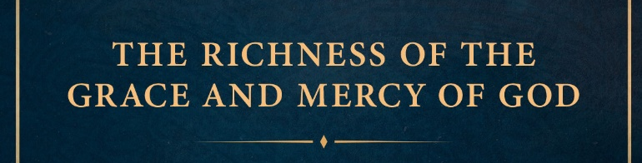
January 18, 9:30am Worship

Silent Prayer of Preparation: Grace alone, which God supplies.

Gathering Songs
“I wonder as” PCC142
“On Christmas night” PCC162
“Carol Our Christmas”
Tolling of the Bell/Welcome
Prayer for Peace: “While Shepherds watched” M236 v6

Call to Worship:
You O God, offer us life, grace, eternity in our time and in your time.
All we have to do is believe, believe that what you say is true, and true for each one.
We sit with you, Lord Christ and we have hope in despair, light in thick darkness
We gather together to be with you God, to grow in our trust and to praise You.

Celebrations (money is not required, any money received goes to meet needs through Naples Angels.)

Prayers of the People/ Lord’s Prayer
Young People’s time

Hymn: “See Amid” (Please stand if you are able) P51

Prayer of Confession: (Unison) Grant us grace, our Father, to do our work this day as workman who need not be ashamed. Give us the spirit of diligence and honest enquiry in our quest for the truth, the spirit of charity in all our dealings with our fellows, and the spirit of gaiety, courage, and a quiet mind in facing all task and responsibilities, (please pray silently). Create in us new life oh Lord, help us shine you in all we do, in Christ we pray. Amen. -Niebuhr
Assurance of Pardon
When we tell our sins to God, God forgives us and cleanses our soul.
The Good news is that in Christ we are forgiven, alleluia!

Response: “The Snow lay” P57 v4

Passing of the peace
Prayer for Illumination: “All Earth is waiting” M210 v1

Psalm 50 Response: Out of Zion, perfect in its beauty, God is revealed in all glory.
New Testament Lesson: Ephesians 1: 3-12
These are the Words of the Lord: Thanks be to God
Sermon: “Richness of God’s Grace” Rev. Stuart C. Buisch
Creed: (Unison) (Please stand if you are able) God’s sovereign love is a mystery beyond the reach of man’s mind. Human thought ascribes to God superlatives of power, wisdom, and goodness. But God reveals his love in Jesus Christ by showing power in the form of a servant, wisdom in the folly of the cross, and goodness in receiving sinful men. The power of God’s love in Christ to transform the world discloses that the Redeemer is the Lord and Creator who made all things to serve the purpose of love. Confession of 1967
Hymn: “Take this moment” (Please stand if you are able) Com Grd 122

Charge (Unison) Therefore, as God’s choice, holy and loved, put on compassion, kindness, humility, gentleness, and patience. Be tolerant with each other and, if someone has a complaint against anyone, forgive each other. As the Lord forgave you, so also forgive each other. And over all these things put on love, which is the perfect bond of unity. The peace of Christ must control your hearts –a peace into which you were called in one body. And be thankful people. Col 3

Benediction

Song: “What Star is this” P68 v3

Announcements
4 PM Chat: Topic- Darkness: Drumbeats
Missions- Courtney’s Can Crusade
Collecting food for Naples Open Cupboard
Soles for Souls- Shoe Donation

Upcoming Events
Annual Meeting- January 25 following the 9:30 am Service with extended coffee hour
The January 25, 11 AM service will begin at 11:10 to provide enough time for the annual meeting.
Council/Trustees Meeting: February 22nd following the 9:30 service

